This predictive model will utilize machine learning, data mining, and statistical   
analysis techniques to identify patterns and trends in the data. The model will   
examine historical data on past travel insurance purchases, demographic   
information, and travel itinerary to predict the likelihood of an individual   
purchasing travel insurance. In this project, we have some database history.of the   
customer as a dataset. The target variable of this dataset is the customer will buy   
travel insurance or not. The goal of this project is to create a predictive model that   
can accurately predict the likelihood of an individual purchasing travel insurance   
based on various factors like Age, Income, Number of Family members etc.

The Predictive Modelling for Travel Insurance Claims project aims to develop a data-driven   
solution to assess the risk of travel insurance claims. Travel insurance is essential for both   
travellers and insurance companies, providing financial protection in case of unexpected   
events during trips. However, insurance companies face challenges in accurately pricing   
policies and managing risks associated with claims. This project seeks to leverage data   
analytics and machine learning to improve the accuracy of risk assessment and enhance   
decision-making in the travel insurance industry.

Travel insurance is a vital aspect of travel planning that provides travellers with   
financial protection against unforeseen events that may occur during a trip. These   
events could include medical emergencies, flight cancellations, lost or stolen   
luggage, and other travel-related mishaps. With the rise in global travel, the demand   
for travel insurance has grown exponentially, with travellers looking for the most   
cost-effective and comprehensive coverage.

The purpose of travel insurance prediction is to leverage data and analytics to enhance   
decision-making in the travel insurance industry. By accurately assessing risk, detecting   
fraud, optimizing pricing, and improving customer experiences, insurance companies can   
provide better services to their policyholders while managing their own financial risk   
effectively.

A literature survey on travel insurance involves reviewing existing academic research,   
articles, and publications related to various aspects of travel insurance. Below, I've provided   
an overview of key themes and findings from the literature on travel insurance up to my last

**TRAVEL INSURANCE PREDICTION**

**2. LITERATURE SURVEY**

**1.INTRODUCTION**

**1.2 Purpose**

**1.1 Overview**

knowledge update in September 2021. Keep in mind that more recent research may have   
emerged since that time.

**2.1 Existing problem**

1. **Data Quality and Availability:** Many travel insurance prediction models rely on   
historical data. However, data quality can be a significant issue, with missing or   
inconsistent information. Additionally, obtaining relevant external data (e.g., weather,   
geopolitical events) can be challenging.   
2. **Limited Historical Data for Uncommon Events:** Uncommon or catastrophic events   
(e.g., global pandemics, natural disasters) can profoundly impact travel   
insurance claims. Modeling these events accurately requires a substantial amount of   
historical data, which may be limited for such rare occurrences.   
3. **Changing Travel Patterns:** Travel behaviour and patterns can change rapidly, making   
it challenging to develop accurate predictive models. Events like the COVID-19   
pandemic have had a significant impact on travel, leading to shifts in travel   
destinations, purposes, and durations.   
4. **Fraud Detection Complexity:** Fraudulent claims in travel insurance can be   
sophisticated and challenging to detect. Fraudsters may use various tactics to deceive   
insurers, making it essential to develop advanced fraud detection algorithms.   
5. **Inadequate Data Privacy and Security:** Handling sensitive customer data in travel   
insurance prediction requires robust data privacy and security measures. Ensuring   
compliance with data protection regulations (e.g., GDPR) is crucial but can be   
complex.   
6. **Lack of Real-Time Data:** Timely information is essential for accurate risk   
assessment and fraud detection. However, accessing real-time data, such as flight   
delays, health advisories, or political instability, can be challenging.   
7. **Model Over fitting and Generalization:** Ensuring that predictive models generalize   
well to new data is crucial. Over fitting to historical data can lead to poor model   
performance when faced with new and unforeseen situations.   
8. **Customer Engagement:** Encouraging travellers to purchase travel insurance and   
providing them with relevant coverage options can be a challenge. Many travellers   
may be unaware of the benefits of travel insurance or perceive it as an additional   
expense.   
9. **Regulatory Compliance:** The travel insurance industry is subject to various   
regulations and laws that can vary by region and change over time. Insurers must   
navigate a complex regulatory landscape to ensure compliance.   
10. **Ethical Considerations:** The use of personal data in predictive modelling raises   
ethical concerns, especially when it comes to profiling travellers and determining their   
risk factors.   
11. **Interconnected Risks:** Travel insurance risks are interconnected, meaning that an   
event in one part of the world can affect claims in another. Managing these   
interconnected risks can be challenging.

There were several existing problems and challenges in travel insurance prediction.   
These challenges are important for the insurance industry to address to improve the   
accuracy of risk assessment, fraud detection, and customer service.

**.Data Cleansing and Standardization:** Implement data cleansing techniques to   
identify and rectify missing or inconsistent data. Standardize data formats to ensure   
consistency across datasets.

**3)Changing Travel Patterns:**

12. **Crisis Management:** The ability to respond to large-scale crises or emergencies, such   
as natural disasters or pandemics, is critical for travel insurers. Developing crisis   
management strategies and predictive models for such events is a complex task.

**2.2 Proposed Solution**

**.Scenario-Based Modelling:** Develop scenario-based modelling to simulate rare   
events using available historical data and expert knowledge. This can help predict the impact   
of unprecedented events.

**2)Limited Historical Data for Uncommon Events:**

**4)Fraud Detection Complexity:**

**8)Customer Engagement:**

**.Education and Personalization:** Educate travellers about the benefits of travel   
insurance through personalized communication. Offer a range of coverage options that cater   
to different travel needs and budgets

**9)Regulatory Compliance:**

**.Real-Time Data Integration:** Integrate real-time data sources, such as flight   
schedules, weather updates, and travel advisories, into predictive models to adapt quickly to   
changing travel behaviour.

**.Machine Learning and AI:** Employ machine learning and AI-based fraud   
detection algorithms that can continuously learn and adapt to new fraud patterns.   
Utilize anomaly detection techniques to flag suspicious claims.

**5)Data Privacy and Security:**

**.Data Encryption and Compliance:** Implement robust data encryption methods and   
ensure strict compliance with data protection regulations. Anonymize or   
pseudonym ize customer data where possible.

**6)Lack of Real-Time Data:**

**.API Integration:** Establish API connections with relevant data providers to access   
real-time information on flights, weather conditions, and geopolitical events.

**7)Model Over fitting and Generalization:**   
 **.Regularization Techniques:** Apply regularization techniques in machine learning

models to prevent over fitting. Continuously update and fine-tune models to adapt to changing   
conditions.

**1) Data Quality Improvement:**

**.Regulatory Monitoring:** Establish a dedicated compliance team to monitor changes in   
regulations and ensure that the company remains compliant. Implement robust data   
governance practices.

**10)Ethical Considerations:**

adapt to large-scale crises. Utilize historical data from past crises for predictive analysis.

**10)Ethical consideration**

**.Ethical AI Frameworks:** Develop and adhere to ethical AI frameworks that   
prioritize transparency, fairness, and accountability in predictive mode ling. Obtain

informed consent for data usage.

**11)Interconnected Risks:**

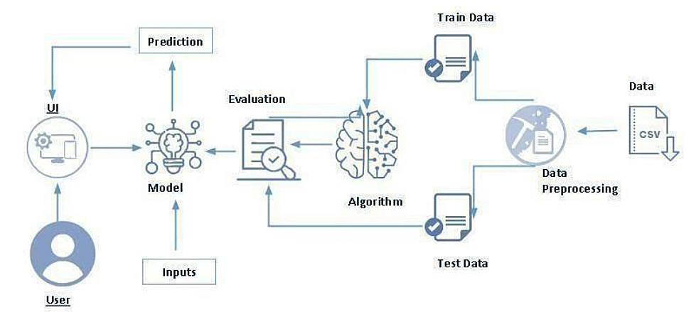

**.Global Risk Assessment:** Collaborate with international partners and   
organizations to assess global risks comprehensively. Develop models that consider

**12)Crisis Management:**   
 **.Crisis Response Protocols:** Develop crisis response protocols and models that can adapt to large-scale crises.utilize historical data from past crises for predictive analysis.

It's important for travel insurance companies to remain agile and proactive in adopting new   
technologies and strategies to stay ahead of emerging risks and changing customer needs.   
Regularly reviewing and updating predictive models is crucial to ensuring their effectiveness   
in a dynamic travel insurance landscape.

**3.THEORITICAL ANALYSIS**

**3.1 Block Diagram**

**Computer/Server:** You will need a computer or server with sufficient processing power   
and memory to handle data preprocessing, model training, and evaluation. The exact   
hardware specifications will depend on the scale of your project. A modern multi-core   
processor and a minimum of 8GB of RAM are typically recommended for small to medium-   
scale projects.

**Python**: Python is the primary programming language for data analysis and machine   
learning. You'll need to install Python along with libraries such as NumPy, Pandas, Diplomatist,   
Sea born, Kitsch-learn, and TensorFlow or PyTorch (for deep learning). You can manage   
Python packages using tools like pip or Conda.

**Operating System:** Most commonly used operating systems such as Windows, macOS,   
or Linux can be used. Linux distributions are often preferred for machine learning projects   
due to their flexibility and compatibility with many data science libraries.

When working on a blood donation prediction project, several investigations are typically   
conducted to understand the data, develop the prediction model, and ensure the project's   
success.

**Storage**: You will need adequate storage space to store your dataset, intermediate files, and   
model artefacts. The storage capacity required will depend on the size of your dataset.

**Feature Analysis**: Explore the distribution of individual features, identify outliers, and check   
for missing values.

**Data Visualization**: Create visualizations such as histograms, box plots, scatter plots, and   
correlation matrices to uncover patterns and relationships in the data.

**Handling Missing Data**: Investigate the causes of missing data and apply appropriate   
techniques, such as imputation or removal, to address missing values.

**Data Profiling**: Investigate the dataset's structure, size, and basic statistics (e.g., mean,   
median, standard deviation) for each feature.

**3.2 Hardware/Software Designing**

**4. EXPERIMENTAL INVESTIGATIONS**

**1. Data Exploration and Understanding**:

**Hardware Requirements:**

**software requirements :**

**2.Data Preprocessing**:

**Algorithm Investigation**: Experiment with various machine learning algorithms (e.g.,   
logistic regression, decision trees, SVM, neural networks) to determine which one performs   
best for the specific prediction task.

**Evaluation Metrics**: Investigate appropriate evaluation metrics (e.g., accuracy, precision,   
recall, F1-score, ROC-AUC) for assessing model performance based on the project's   
objectives.

**Hyper parameter Tuning**: Investigate different hyper parameter settings through techniques   
like grid search or randomized search to optimize model performance.

**Outlier Detection**: Investigate potential outliers and decide whether to remove them or   
transform them to improve model robustness.

**Data Scaling/Normalization**: Investigate the need for feature scaling or normalization,   
especially if the chosen machine learning algorithm requires it.

**Monitoring**: Investigate how to set up continuous monitoring of the deployed model's performance and   
conduct regular audits to ensure it continues to meet its objectives

**3.Model Selection and Training**:

**5.Deployment and Monitoring**:

**5. FLOWCHART**

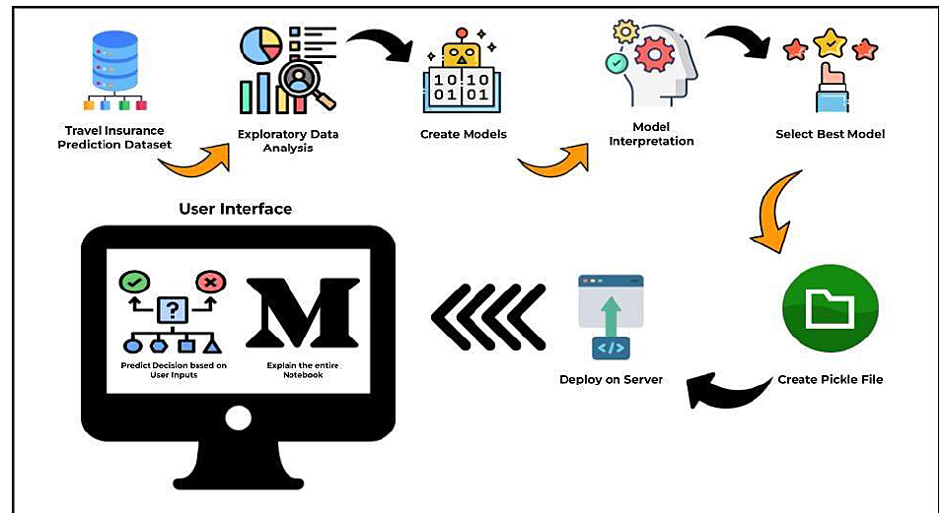

**Deployment Investigation**: Investigate the deployment process, including selecting the   
appropriate environment (e.g., cloud or on-premises) and integrating the model into the   
production system.

**4.Model Evaluation**:

**6.RESULT**

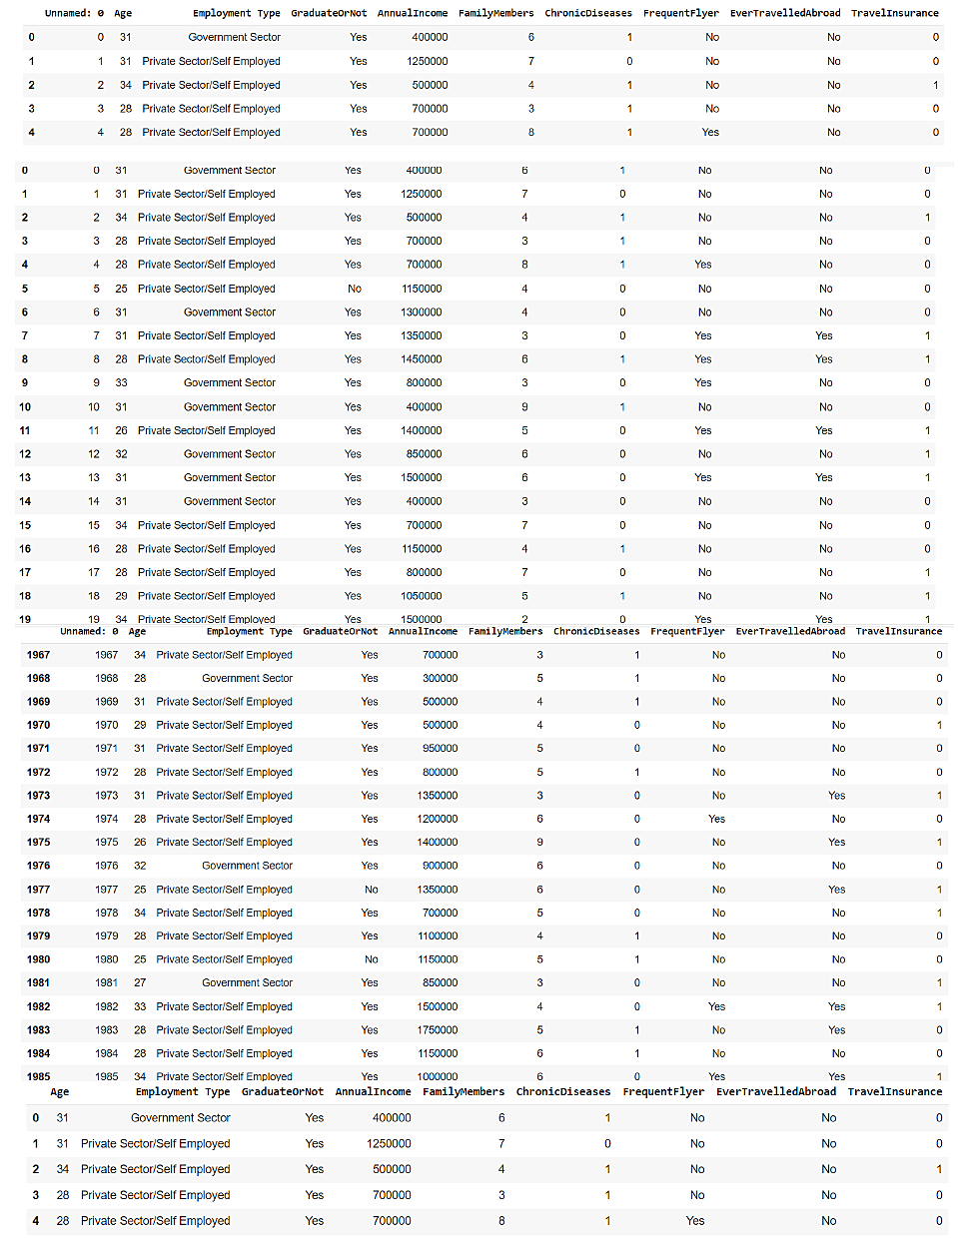

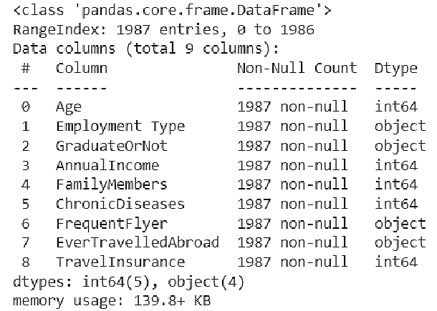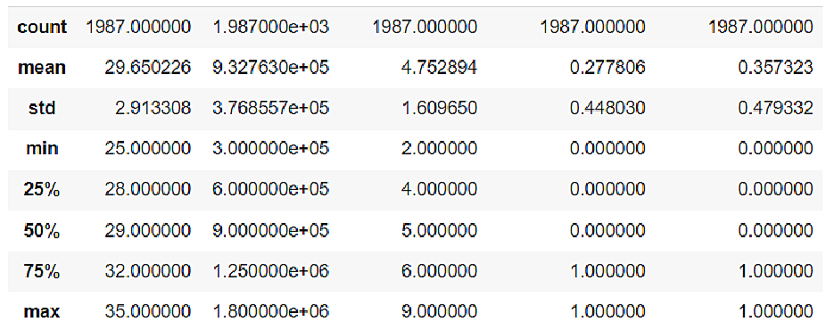

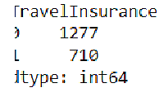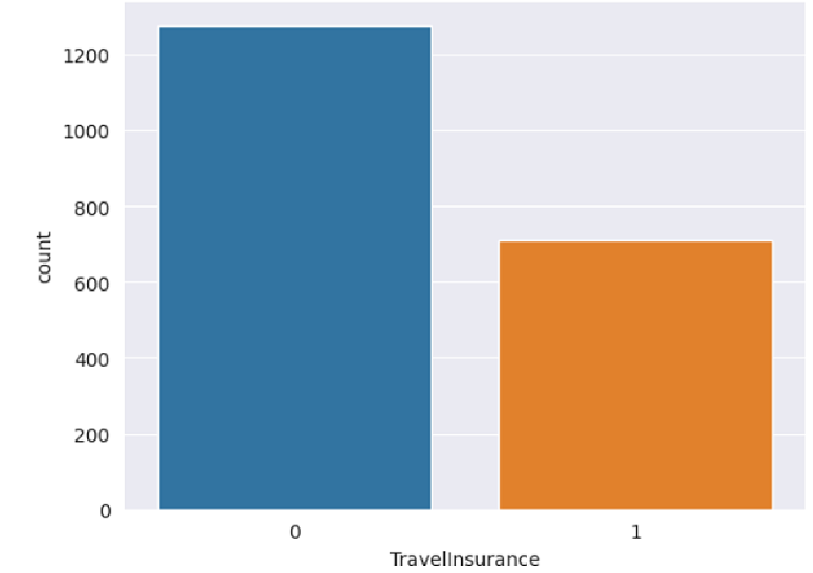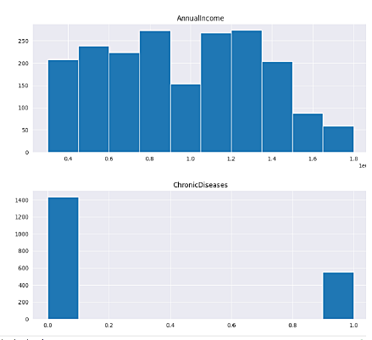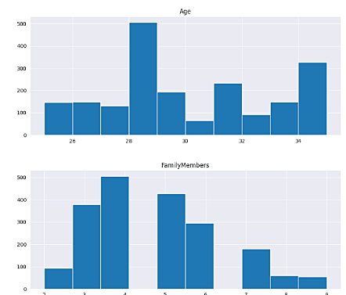

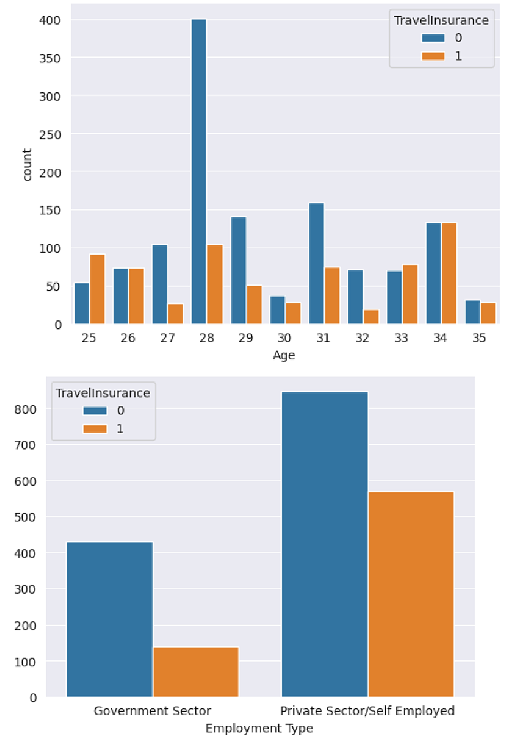

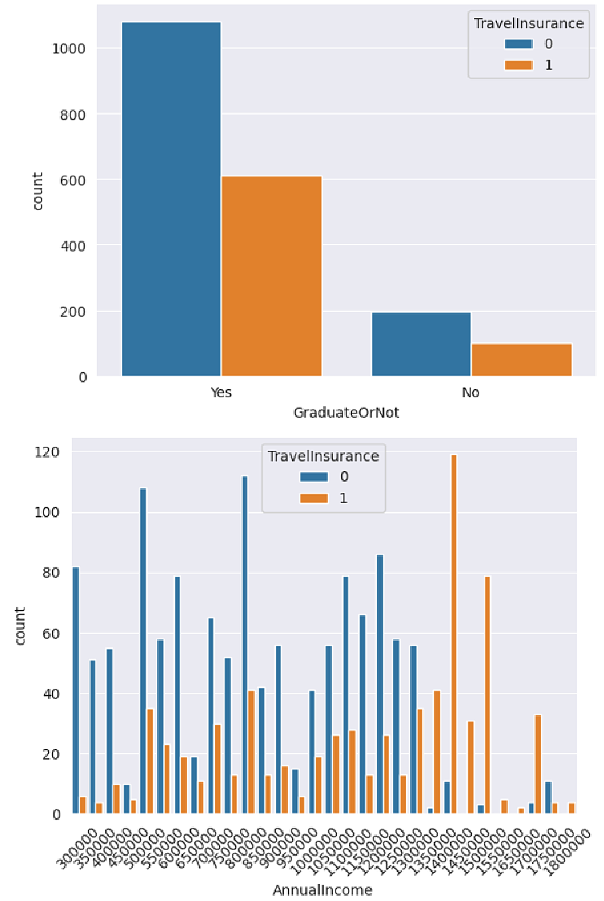

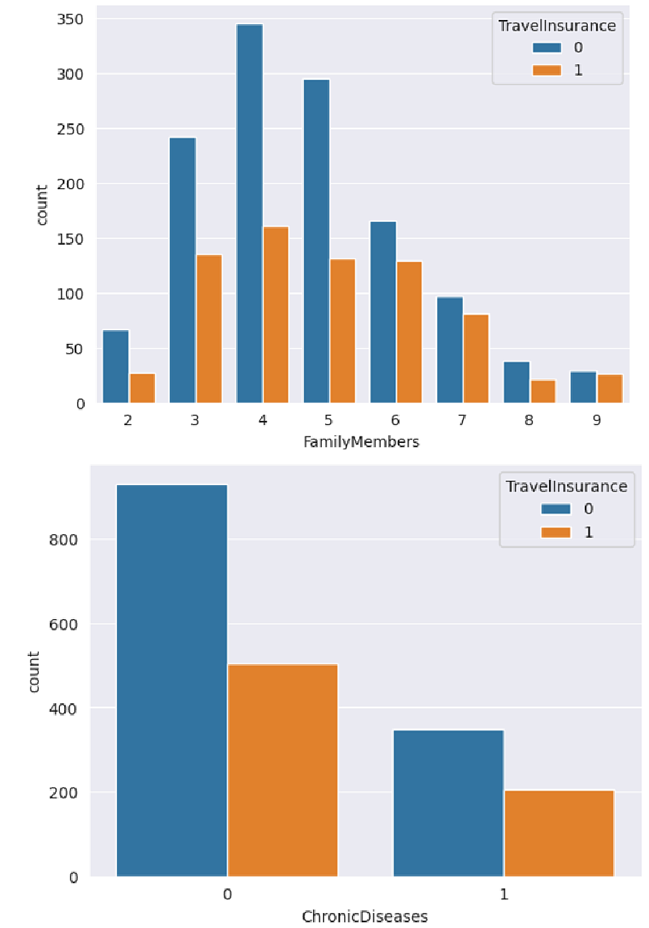

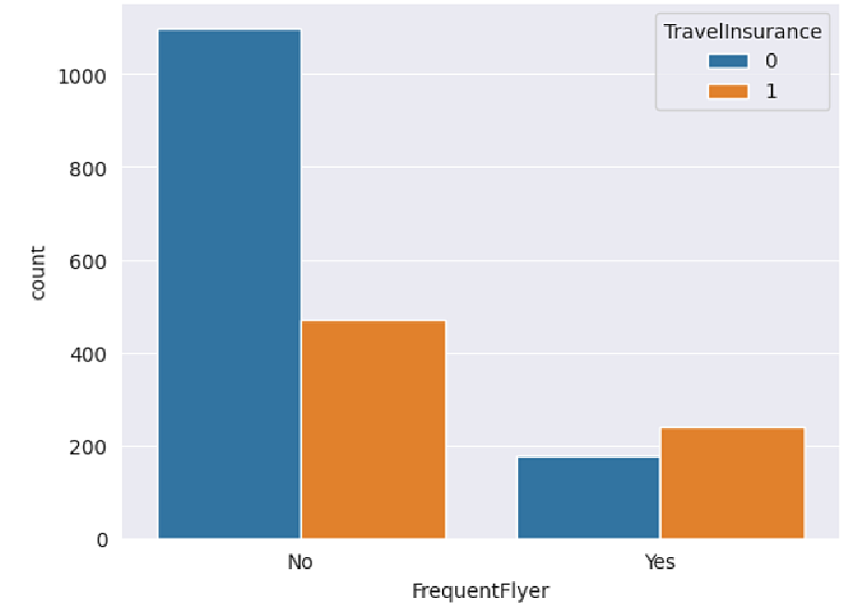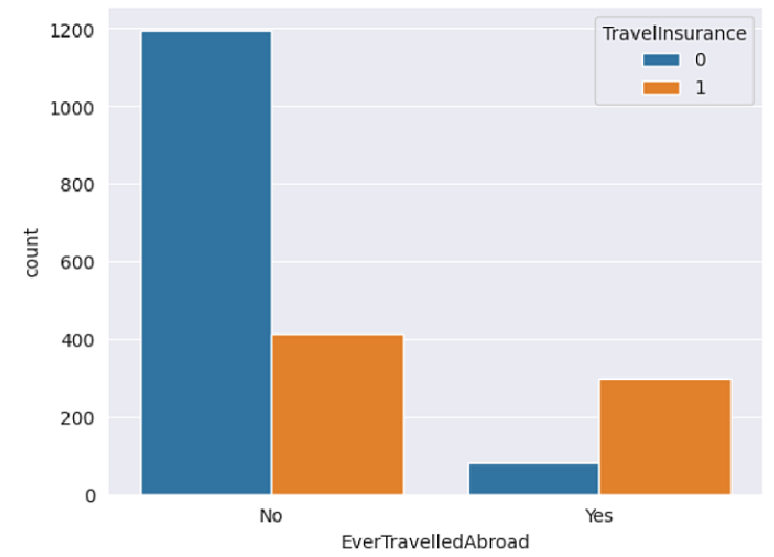

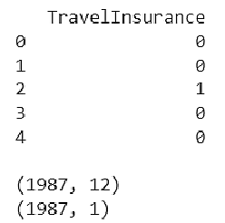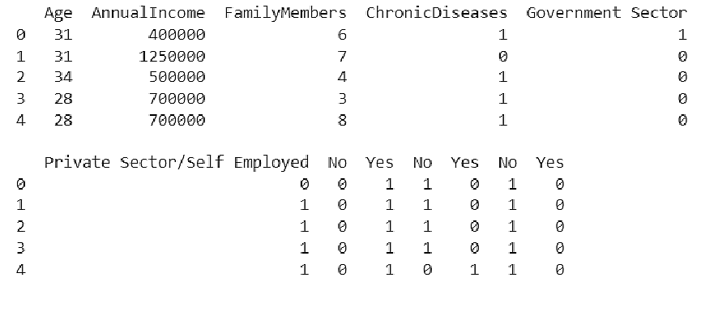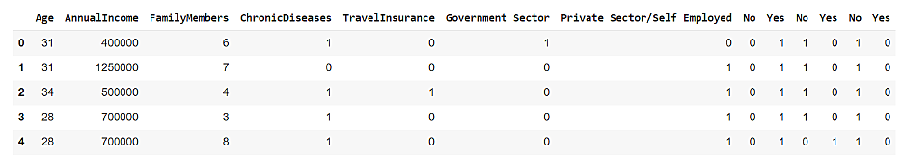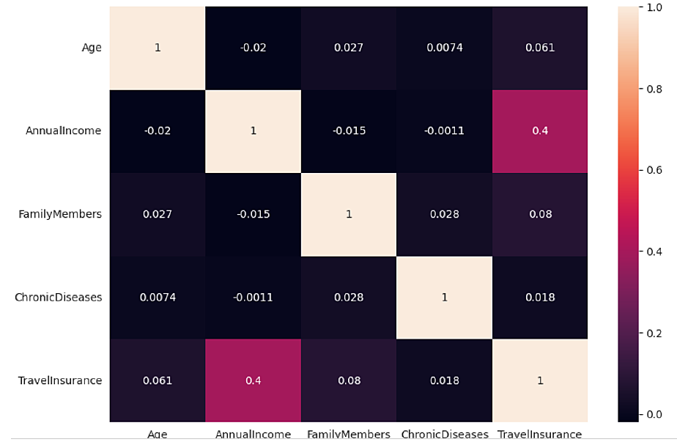

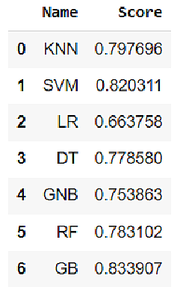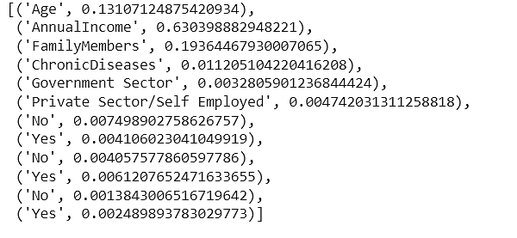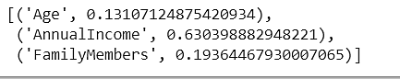



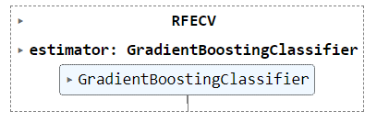

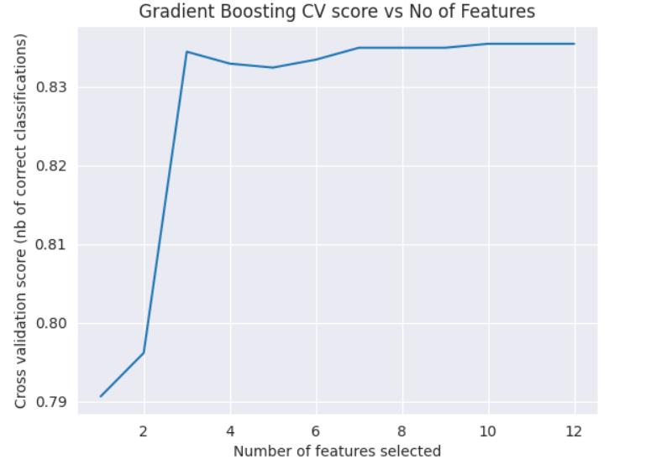

**7. ADVANTAGES & DISADVANTAGES**

Travel insurance prediction offers several advantages for both insurance companies and   
travellers. These advantages contribute to more efficient and customer-centric insurance.   
services.

**Disadvantages:**

1. **Improved Risk Assessment:**   
• Travel insurance prediction models enhance insurers' ability to assess risks   
accurately. By analysing various factors, including traveller profiles, trip   
details, and historical data, insurers can better understand the likelihood of   
claims, allowing for more precise pricing and risk management.   
2. **Optimized Premium Pricing:**   
• Predictive models help insurance companies set appropriate premium rates   
based on risk profiles. Travellers benefit from fairer pricing that aligns with   
their individual risk factors, potentially leading to cost savings for low-risk   
travellers.   
3. **Fraud Detection and Prevention:**   
• Advanced analytics and machine learning in travel insurance prediction assist   
in identifying fraudulent claims more effectively. This reduces the financial   
impact of fraudulent activities and helps maintain the integrity of the insurance   
system.   
4. **Personalized Insurance Products:**   
• By segmenting customers based on their risk profiles and preferences, insurers   
can offer personalized insurance products. This enhances the customer.   
experience and ensures that travellers receive coverage tailored to their specific   
needs.   
5. **Enhanced Customer Experience:**   
• Travellers benefit from a more streamlined and efficient insurance purchasing   
process. They can access quotes and purchase policies more quickly, making it   
easier to secure coverage for their trips.   
6. **Cost Savings:**   
• By accurately assessing risk and detecting fraud, insurance companies can reduce   
their claims payouts and operational costs. These cost savings may be passed on to   
customers through competitive pricing.

1. **Data Privacy Concerns:**   
• The collection and analysis of personal data for predictive modelling raise   
privacy concerns. Travellers may be uncomfortable with the extent to which   
insurers use their data for risk assessment and pricing.   
2. **Ethical Considerations:**   
• The use of predictive models in insurance can lead to ethical dilemmas. For   
instance, there may be concerns about discrimination or bias in risk   
assessments, leading to unfair treatment of certain groups of travellers.

**Advantages:**

3. **Accuracy Limitations:**   
• Predictive models are based on historical data and assumptions. They may not   
always accurately predict future events, especially for rare or unprecedented   
situations like global pandemics or geopolitical crises.   
 **4 Model Complexity:**   
• Building and maintaining complex predictive models can be resource-intensive.   
Smaller insurance companies or those with limited technical capabilities may struggle   
to implement and manage such systems.   
•   
• perceive them as a threat to their role in the sales process.   
**5.Data Quality Issues:**   
• Data used for predictive modelling must be accurate and up-to-date. Inaccurate   
or incomplete data can lead to flawed predictions.   
•   
• **Complexity for Small Insurers:**   
• Smaller insurance companies may lack the resources and technical expertise to   
implement and maintain sophisticated predictive models.

• Predicting the likelihood of a traveller filing a claim based on various factors such as   
age, destination, travel duration, and past travel history. This helps insurance   
companies understand the risk associated with each policyholder.   
• **Fraud Detection:**   
• Identifying suspicious or potentially fraudulent claims using predictive   
analytics. This involves analysing claim data, customer behaviour, and   
historical fraud patterns to flag potentially fraudulent activities.   
• **Customer Segmentation:**   
• Segmenting policyholders into different groups based on their risk profiles and   
preferences. This allows insurance companies to offer customized insurance.   
products and pricing to different customer segments, such as frequent   
travellers, families, or business travellers.   
• **Policy Recommendation:**   
• Recommending insurance policies tailored to a traveler's specific needs and   
trip details. Predictive models can suggest coverage options that align with the   
traveler's destination, activities, and potential risks.   
• **Real-time Risk Assessment:**   
• Providing real-time risk assessments for travellers based on changing   
conditions such as weather, political stability, or health advisories. Travellers   
can receive alerts and advice to mitigate risks during their trips.   
• **Claims Processing Automation:**   
• Automating the assessment of insurance claims using predictive models. This   
streamlines claims processing, reduces turnaround times, and minimizes the   
need for manual reviews of straightforward claims.

**Risk Assessment:**

**8. APPLICATIONS**

impossible for the sales person in the travel agency to assess whether a customer would be   
likely to purchase travel insurance with his/her travel package. With the white box models   
performing significantly less accurately, it is thus recommended that the IT system of the   
travel agency be enhanced to run the model backend as part of the point of sale system or to   
train the staff to run the model as part of their sales process.

In conclusion, a travel insurance prediction project offers significant advantages for both   
insurance companies and travellers. By harnessing the power of data analytics and predictive   
modelling, this project aims to enhance the entire travel insurance ecosystem, from risk   
assessment and pricing optimization to fraud detection and customer experience   
enhancement.

• Providing travellers with personalized travel advisories and recommendations based   
on their destination, travel dates, and potential risks. Predictive models can help   
travellers make informed decisions about their trips.

**10. FUTURE SCOPE**

**9.CONCLUSION**

1. **Integration of Real-time Data:** Travel insurers will increasingly rely on real-time   
data sources, such as weather updates, flight schedules, and geopolitical events, to   
provide travellers with up-to-the-minute risk assessments and coverage   
recommendations. This will enable insurers to adapt rapidly to changing travel   
conditions and offer more relevant coverage options.   
2. **AI and Machine Learning Advancements:** Advancements in AI and machine   
learning techniques will lead to even more accurate risk assessments and predictive   
models. Deep learning algorithms, natural language processing, and reinforcement   
learning will become more prominent in the analysis of travel-related data.   
3. **Personalized Coverage Recommendations:** Travel insurance will become highly   
personalized, with predictive models tailoring coverage recommendations to   
individual travelers' profiles, preferences, and itineraries. Travellers will have the   
option to select coverage that aligns precisely with their unique needs.   
4. **Enhanced Fraud Detection:** Predictive models for fraud detection will become   
more sophisticated, incorporating anomaly detection, network analysis, and social   
network analysis to identify fraudulent activities more effectively.

The future of travel insurance prediction projects is expected to be shaped by various   
technological, regulatory, and industry trends. Here are some future predictions for travel   
insurance prediction projects:

**Travel Advisory Services:**

References of previous works or websites visited/books referred for   
analysis about the project, solution previous findings etc.

APPENDIX   
A. Source Code   
Attach the code for the solution built.

**11.BIBILOGRAPHY**